**Experiment No: 11**

**Title:** Case Study on Amazon EC2.

**Aim:** To perform case study on Amazon EC2.

**Case Study:**

**What is AWS?**

Amazon Web Service is a subsidiary of Amazon providing on-demand cloud services and API’s to individuals, companies, and governments on metered as per pay-as-you-go basis.Amazon Web Service is the most comprehensive and broadly adopted cloud platform, offering over 175- full fledged services. And the Aws is used by all fast-growing start-ups, large enterprises, and the lead government organization to lower the cost and become more agile and innovate more faster.

**Aws Data Center:**



**AWS Region**

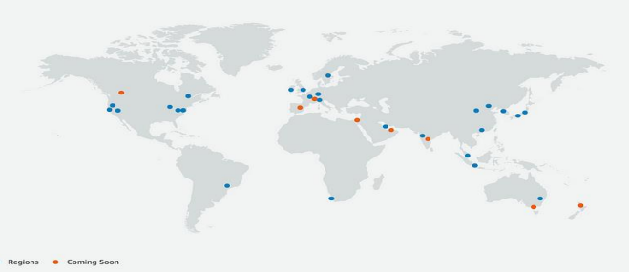

Amazon Web Services (AWS) currently has 26 regions in operation and a further 8 under development, meaning that the company will have a total of 34 regions available by the end of 2024.

Within each AWS region are 3 to 6 isolated, and physically separate locations, known as availability zones, which have independent power, cooling, and physical security, and are connected to each other with a redundant, low-latency, private fiber-optic network.

Presently, Amazon Web Services (AWS) has 84 availability zones in operation and a further 24 under development, meaning that the company will have a total of 108 availability zones existing by the end of 2024.

Top Most Succesful Company that use AWS:

**Adobe Systems :**

Adobe Systems provides digital media and marketing solutions to customers around the world including individual consumers, enterprises, and government agencies.

They were recently named the “#1 Computer Software Company” on FORTUNE Magazine’s list of the “World’s Most Admired Companies”. Through their creative, marketing, and document solutions, Adobe seeks to empower all users to bring their digital creations to life and deliver them to the appropriate audience in a timely manner.

Adobe takes pride in inspiring creativity around education, sustainability, and community and to do so, they need to deliver a quality product that every customer, from individual users to global companies, can easily access. The solutions that Adobe offers help solve the marketing needs for a variety of industries, from data-driven marketing to programmatic advertising.

To enable them to deliver high-quality products, Adobe focuses on maintaining a large community of customers, partners, and employees with experience in content development and optimization.

**ADOBE AND AWS:-**

Adobe Systems delivers enterprise software to Fortune 100 companies, large multi-national corporations, and government agencies. Adobe uses AWS to provide multi-terabyte operating environments for products like Adobe Creative Cloud and Adobe Digital Marketing Cloud, so the company can focus on deploying and operating its own software instead of infrastructure. Adobe Systems provides digital media and digital marketing solutions to customers around the world including consumers, enterprises, and government agencies. By using the AWS Cloud, Adobe can focus on delivering its software products without having to invest in expensive infrastructure.

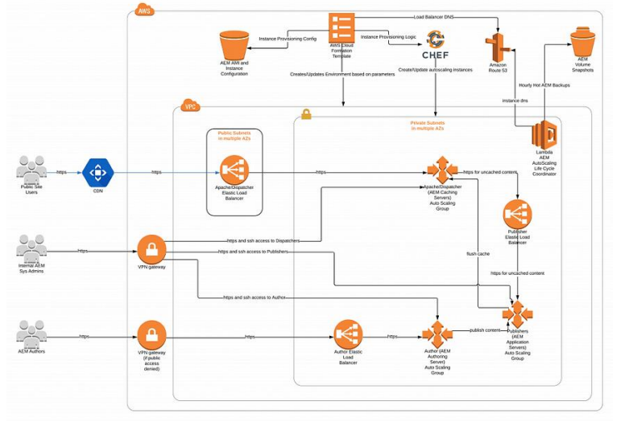

**SERVICES:-**

Adobe provides several products and using AWS helps it maintaining the quality and experience for their customers. Managed services like -

**Adobe Experience Manager:-**

Adobe Experience Manager (AEM) helps organizations create, manage and optimize digital customer experiences across every channel: web, mobile web and apps, digital forms, and communities:

1. Quickly create and deliver digital experiences and update the content anytime, without burdening IT
2. Easily manage images, videos, and other digital assets to deliver engaging customer experiences with dynamic and personalized media and video
3. Build thriving communities consisting of blogs, forums, events, and product reviews across all your social properties
4. Rapidly create, deliver and update mobile apps with an integrated mobile application development platform
5. Create forms into all of your digital experiences; simplify the creation of forms and the complexity of transactions.

**Adobe Connect :-**

Adobe Connect is a web conferencing platform for web meetings, eLearning, and webinars. It powers mission-critical web conferencing solutions end-to-end, on virtually any device, and enables organizations to fundamentally improve productivity.

This is a single-tenant, hosted offering managed by Adobe Connect experts. It leverages Amazon’s Elastic Compute Cloud (Amazon EC2) service to provide “on the fly” scaling of resources along with enhanced flexibility, customization, and security options.

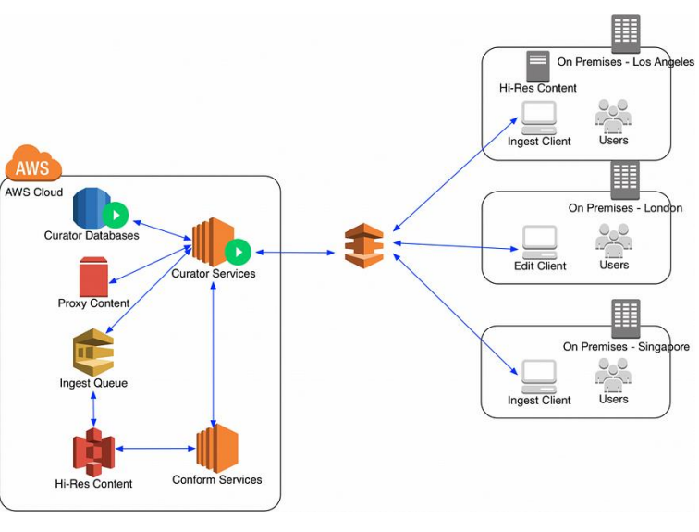

Using Amazon AppStream to stream Adobe Creative Cloud applications simplifies the IT management and overhead required to manage streaming applications while providing remote virtualized access to Adobe Creative Cloud applications anywhere, on the go, and on lowpowered devices

This implementation guide provides a guided approach to set up Adobe Creative Cloud applications on Amazon AppStream to evaluate the setup for your organization's business objectives.

**Conclusion:**

As technological innovation continues to accelerate, the need for continuous digital transformation will become even more pressing.

Thus, I have studied case study on Amazon EC2.